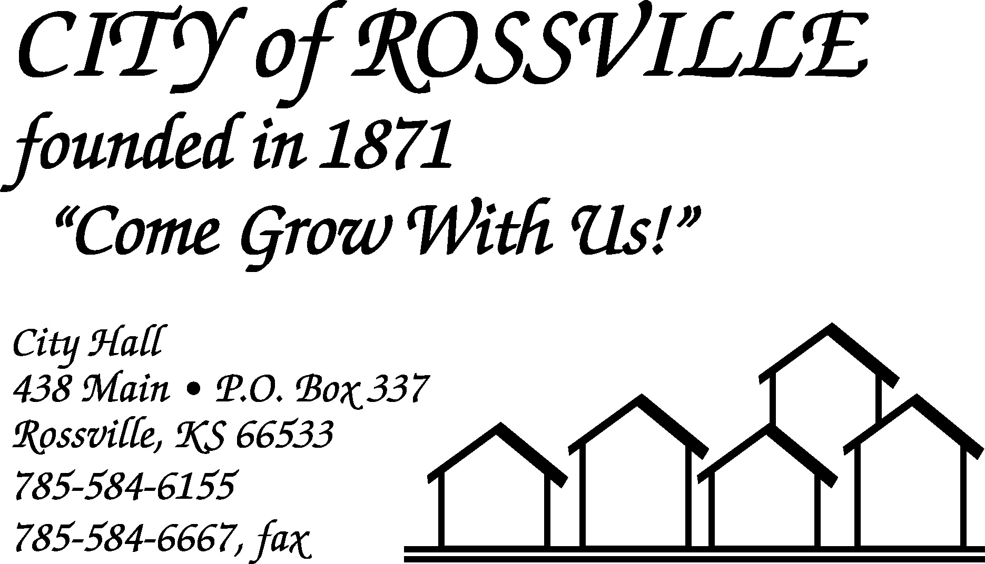

City Hall June 20, 2022

The Rossville City Council meeting was called to order on Monday, June 20, 2022 at 5:59 pm by Mayor James Meyer.

Council members present were Todd Reeves, Trish Heim and Dan Glotzbach. Toby McCullough was absent.

Also present were Alan Zlatnik and Jason Connell.

Motion by Dan Glotzbach to approve minutes of the June 6, 2022 meeting as written was seconded by Trish Heim and carried.

The following bills were presented;
EFTPS-Fed WH $1,086.85 Alan Zlatnik $1,819.68
EFTPS-FICA 2,210.34 Tracey Taylor 926.18
EMPower Retirement 447.00 Lisa Stum 1,193.83
Grace Hier 150.00 Kansas Payment Center 123.69
Michael Kirk 1,574.54 Randall Anderson 849.14
Kansas Withholding Tax 534.23 KP & F 1,195.33
Douglas Schreiner 46.75 Jason Connell 1,021.67
KPERS 1,450.66 Tina Dick 492.05
Trent Stanley 1,386.80 Jacob Akin 118.10
Amazon.com 20.97 Evergy 1,782.16
Fastdraws 46.29 Ks Dept of Health & Environ 304.00
Shawnee Co. Solid Waste Dept. 7,216.16 Twilio 50.00
U.S. Post Officer 214.00 Microsoft 8.00
US Bank 54.64 US Bank 54.28
Yahoo 23.99 Zoom Video Communications Inc. 14.99
Blue Cross Blue Shield of Ks. 9,943.32 Continental Research Corp 752.79
DH Lawn & Garden Equipment 107.97 Donn Womack 75.15
Gray’s Auto Repair 431.26 Jackie Miller 75.14
Casey’s 2,259.58 Kristen Lee 75.15
Langley Bryant 75.06 Century Business Technologies 194.37
Evergy 2,888.17 Matthew Kaiser 75.02
Menards 179.91 Kansas Gas Service 101.80
Rossville Community Recreation Assoc 2,000.00 Rossville Water Service 300.36
Rossville Water Service 300.58 Stum’s Concrete 228.00
Supreme Bar LLC 75.15 Universal Chemical LLC 1,361.61
Maguire Iron, Inc. 165,400.00 Ks State Treasurer-Court 211.50
TOTAL 213,528.21

Motion by Todd Reeves to pay bills as presented totaling $213,528.21 was seconded by Dan Glotzbach and carried.

Motion by Dan Glotzbach to approve agenda as presented was seconded by Trish Heim and carried.

Discussion of 2023 budget was tabled as figures from Shawnee County had not been received yet.

Council discussed applicants to fill vacant City council position. Following discussion Mayor James Meyer appointed Taylor Morelli as City councilmember. Motion by Trish Heim to approve appointment was seconded by Dan Glotzbach and carried.

Mayor reminded council that next meeting would be on Tuesday, July 5, 2022 due to the holiday.

Utility Superintendent Alan Zlatnik reported that the newly painted water storage tank had been filled and operating for about 12 days and that site cleanup was completed today.

Superintendent Zlatnik reported that Catron Construction was working with City insurance on quote for repairs to park shelter house.

Superintendent Zlatnik reported that KDHE had inspected sewer lagoon and found no violations. However they were recommending that the City bring lagoon fence up to state standards with additional string of wire and make repairs to old section of fence. Zlatnik presented bid to replace and upgrade fence in the amount of $22,000.00. Council to look at budgeting expense next year or doing in stages over the next few years.

Police Chief Jason Connell reported that the police department would be compiling code enforcement report for next meeting.

Mayor requested that employee salary review be tabled until July 18, 2022 meeting.

Refund of fireworks stand permit fee to the Rossville American Legion Post #31 was tabled until breakout of fees can be received from the Legion.

Council reviewed draft of Exercise Trail Agreement and noted that they would like to change name of trail to something like “Cross Creek Trail” and discussed section 5 dealing with control of weeds and maintenance, noting that it was their understanding that Rossville Foundation volunteers were going to assume this responsibility. No action was taken at this time.

Council inquired about hole next to sidewalk left by fallen tree on Dennis Sumner property. Mayor to contact Sumner to advise.

Council had discussion regarding sidewalk construction in Kross #1 subdivision. Following discussion, it was concluded that protective covenant states that no sidewalk is required until construction of dwelling on said lot is completed.

Harry Hammer III arrived at 7:01pm.

Clerk presented request for easement change at 619 Main. Council noted that this would be Shawnee County easement. Superintendent Zlatnik to check drainage and Mayor to contact property owner regarding permission from Shawnee County.

Resolution waiving the requirements of K.S.A. 75-1120a(a) as they may apply to the City of Rossville for the year ended December 31, 2022 and causing the financial statements and financial reports of the City of Rossville to be prepared on the basis of cash receipts and disbursements as adjusted to show compliance with the cash basis and budget laws of this State was presented. Motion by Todd Reeves to adopt Resolution was seconded by Dan Glotzbach and carried.

Application for demolition permit for demolition of carport at 247 Main was presented. Motion by Trish Heim to approve permit was seconded by Todd Reeves and carried.

Application for demolition permit for demolition of carport at 614 Griswold Ct. was presented. Motion by Trish Heim to approve permit was seconded by Todd Reeves and carried.

Council had discussion regarding possible code violations at 437 Orange and persons possible living in camper. Chief Connell to check on issues.

Harry Hammer III discussed concerns about crosswalks on Highway 24. Mayor to make some calls to determine possible actions.

Motion by Trish Heim to adjourn was seconded by Dan Glotzbach and carried. Meeting adjourned at 7:24 pm.

Lisa M. Stum
City Clerk

